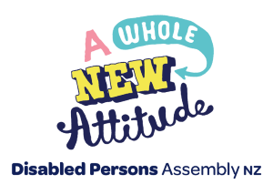

Disabled Persons Assembly NZ (DPA)

Candidate information for members voting for the National Executive Committee

2026

Juliana Carvalho 3
Nominated for: President Elect
Tania Ali 5
Nominated for: Committee member
Tara Shepherd 7
Nominated for: Committee member
Elliot Yates 10
Nominated for: Committee member

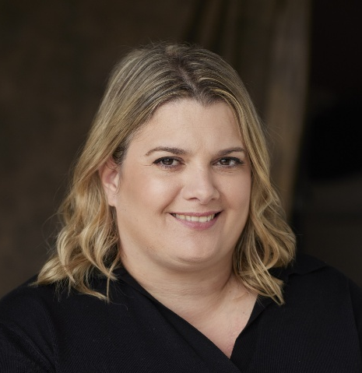
Juliana Carvalho

Nominated for: President Elect
Nominated by: Joanne Dacombe
Why Juliana has been nominated
I am nominating Juliana as President Elect as she has the required skills and commitment to DPA and the NEC. She is a very active member of DPA and the NEC capable of leadership of the NEC. Juliana is a passionate advocate and active in disability and accessibility rights. Juliana has the necessary skills as well as a number of important disability and funder connections.

About Juliana
Are you a full member of DPA?
A full individual member
How long have you been a member of DPA?
Unsure, likely 4 years. NEC member for the past 2 years.
Tell us a little about yourself
Juliana Carvalho is a Brazilian disability rights advocate. She became paraplegic at 19 and transformed her experience into a mission to drive change. She created and hosted the public television show “Make a Difference”, directed the award-winning short film “If the Eyes Cannot See, the Legs Cannot Feel”, and won Marie Claire Brazil’s Best True Story Award.
Her autobiography “In My Chair or Yours?” has sold more than 30,000 copies in Brazil, and the English edition reached the Top 100 Hot New Releases on Amazon.com.
Since 2012, Juliana has called Aotearoa New Zealand home. Her resilience and courage in challenging the discriminatory immigration system sparked a movement to overturn the “acceptable standard of health” policy. Her petition—backed by over 35,000 signatures—alongside a bold video campaign featuring shark diving and paragliding, drew widespread media attention and helped expose ableist barriers in immigration policy.
Today, as a campaigner, speaker, and strategist, Juliana is leading the national push for enforceable accessibility legislation. She is a powerful voice in the disability rights movement, bringing lived experience, fearless storytelling, and strategic leadership to ensure accessibility is recognised as a human right—not a privilege. Through humour, passion, and radical disability pride, Juliana challenges perspectives and advocates for a more inclusive world.
Why do you want to become a member of the DPA NEC?
I’m committed to advancing disability rights in Aotearoa and strengthening our collective voice.
What is your knowledge and understanding of Te Tiriti o Waitangi?
I have a good understanding. I’m committed to upholding its principles in my work and advocacy.
What is your understanding of the social model of disability, the United Nations Convention on the Rights of Persons with Disabilities (the UNCRPD)?
I have a great understanding and they inform my work and advocacy.
What governance experience do you have?
I have served on four boards and completed Institute of Directors training.
What skills would you bring to the NEC
- Disability rights and justice advocacy
- Governance skills and experience
- Strategic planning
- Strategic funding
Conflict of interests:
I am a current NEC member and hold multiple roles in the disability sector. I run my own consultancy business, am currently contracted with Auckland Council as an implementation partner engagement for a disability-led climate adaptation pilot and am establishing a new charitable trust called Disability Disruption.


Tania Ali

Nominated for: Committee member
Nominated by: Jasmin Taylor
Why Tania has been nominated
Tania is Māori Turi, has lots experience advocating for Deaf community and providing advice about accessibility. She supports Māori Turi and Muslim communities in Wellington. I know Tania will bring a valuable perspective to Disabled Persons Assembly committee. She has experience working with Wellington City Council and on Parliament's Accessibility Reference Group.

About Tania
How long have you been a member of DPA?
Yes, I was old DPA member for few years in history (25 years ago) then I got come back to DPA member again. I become a member for about 3 years ago. I still a member. I will love to go back to DPA to support for Māori Deaf by DPA member
Tell us a little about yourself
- Ko Ngapuhi and Ngati Tuwharetoa toku Iwi
- Ko Waikare and Turangi toku hapu
- Ko Tania ahau ingoa. I have 3 daughters and mokos.
- I am passionate about Accessibility and support to the Disability come first who need this.
Why do you want to become a member of the DPA NEC?
I am happy to learn more opportunities for myself to work and listen to our community and want to keep our DPA team strong and move forward into the future and new generations.
What is your knowledge and understanding of Te Tiriti o Waitangi?
- It involves understanding and valuing the contributions of both Māori and Pakeha cultures, as well as the rights and perspectives of tangata whenua (the people of the land).
- Partnership: The Crown and Māori must work together.
- Protection has been provided to Māori rights and keeps the Māori Iwi people with Disability people and NZSL service, for the NZSL Act 2006. and more consultation with Māori who need to know more clearly.
- Yes, I understand and always participate and work with the people in NZ
What is your understanding of the social model of disability, the United Nations Convention on the Rights of Persons with Disabilities (the UNCRPD)?
Important for the participation of people with disability in everyday life, including decision-making and process, opportunities and social interaction. Advocacy and social can show the roles in promoting the rights and inclusion, and our voice and policy and advocates can work together to create equity and equality and inclusive for everyone
What governance experience do you have?
Yes, I have experience from my skills as Executive member from Deaf Aotearoa for 10 years.
Please select any of the following skills you would bring to the NEC
- Indigenous rights advocacy
- Disability rights and justice advocacy
- Business management
- Financial expertise
- Governance skills and experience
- Legal knowledge
- Strategic planning
- Risk management
- Accessibility and digital and typing fast speed with laptop
Is there anything else that you would like to share with us that is relevant to your nomination?
Make sure clear and understand and support you all and listen to your real-life experience. I have much experience and skills with project management and GOOD SPEED TYPING FAST in anything to support you all and digital, and my passion is ACCESSIBILITY. Also, make sure to bring the NZSL interpreter so be there and can use the NZ relay service will be useful.
Visual and clear view and understanding and translation and captions in Zoom.
Conflict of interests: none declared.

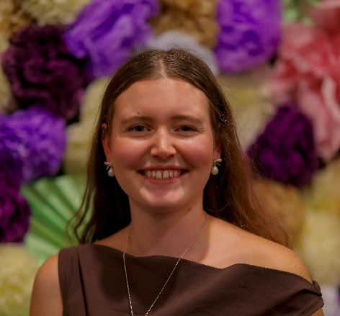
Tara Shepherd

Nominated for: Committee member
Nominated by: Kera Sherwood-O’Regan
Why Tara has been nominated
I have had the privilege of working alongside Tara on the NEC for the past few years, and have found her to be a real asset to our board. She has strong governance experience, with all the key skills we are looking for on the NEC, and additionally brings unique perspectives to our discussions and decision-making as a staunch advocate for youth and rural disabled communities.
Tara’s prior experience on the National Disabled Students’ Association and other boards has been invaluable in bringing fresh ideas and different ways of working to the DPA NEC. This has been incredibly useful in the Constitution Update and Strategic Development work streams in particular, where she has been able to suggest skills or practices from her experience that we can pick up and adapt to a DPA context. She has also been able to lead governance skill-share items in our Strategy & Planning days which have been very useful and demonstrated her commitment to growing and developing her skills in this area.
She has a genuine commitment to DPA’s values, and a strong grounding in disability rights, Te Tiriti, and our other foundational documents and frameworks. In particular, she has been committed to the wellbeing of DPA staff, NEC, and members, and to ensuring that our work better considers the needs of rural disabled people. Overall, Tara has been a valued member of the NEC during her term, and I believe DPA would greatly benefit from an additional term with Tara on our committee.

About Tara
Are you a full member of DPA?
A full individual member
How long have you been a member of DPA?
3 years

Tell us a little about yourself
Tara’s mahi sits at the intersection of disability advocacy, rural communities, climate-resilient infrastructure, and mobilising people. She is passionate about emergency management that stems from her experience coordinating Westport’s waste recovery during the 2021 floods, removing 1,100 tonnes of waste—work that shaped national emergency response frameworks and highlighted the need for accessible, resilient infrastructure.
With over a decade of advocacy, Tara has held roles such as Co-President of the National Disabled Students’ Association (2023–24), contributed to education policy spanning from early learning through to university, and has served on the Disabled Persons Assembly National Executive and Whakapuāwai Taskforce. A Kiwibank Local Hero medalist, she is currently a UNESCO Aotearoa Youth Leader amplifying rural, youth, and disabled voices globally.
Why do you want to become a member of the DPA NEC?
I bring a skill set to the governance board that can help maintain and aid in the direction of our organisation. I personally believe it is important to bring in youth-voice to these spaces to promote succession planning, development opportunities and the possibility to expand our membership. I am proud of the mahi the board has undergone in the last two years and I feel as if I still have the dedication willing to continue to represent our collective with dignity.
What is your knowledge and understanding of Te Tiriti o Waitangi?
Our history is more than the words upon the page, but the commitment to continue equitable decision making with Māori and holding ourselves responsible to support Te Reo to ensure it can prosper. It is important we represent Aotearoa honestly, the ever-ongoing treaty relationship that recognise mana whenua as founding people. It is important we uplift indigenous perspectives globally and ensure than collaboration or commitments align with the treaty principles. I count myself as a life-long learner and give every effort to introduce in mihi, karakia but also encourage others to take part. I aspire towards a better Aotearoa for our equity groups.
What is your understanding of the social model of disability, the United Nations Convention on the Rights of Persons with Disabilities (the UNCRPD)?
I believe in universal design aligned with the social model to ensure environments are accessible to all. I often cite the UNCRPD as a foundational framework that affirms shared rights and unity among disabled people globally. UN Women data highlights that wāhine with disabilities remain severely underrepresented; a 2017 dataset showed that in 14 of 18 Asia–Pacific countries, no female parliamentarians identified as disabled. These statistics demonstrate persistent barriers to education, financial support, and participation in decision-making. The intersection of gender and disability underscores the urgent need for comprehensive, inclusive policies, particularly for those in rural communities.
What governance experience do you have?
Over a decade of advocacy, Tara has had roles on a variety of boards and built skills to draw on.
Please select any of the following skills you would bring to the NEC.
- Disability rights and justice advocacy
- Governance skills and experience
- Strategic planning
- Risk management
- Strategic funding
Conflict of interests: none reported


Elliot Yates

For Committee member
Nominated by: Joanne Dacombe
Why Elliot has been nominated
Elliot has been involved with politics helping to develop disability policy. He's contributed writing articles to the magazine of Te Awa regarding disability, discussing disability topics, interacted with MPs regarding disability topics and also creating opportunities for other disabled people to become leaders.
He has advocated for disabled people for a while in the public arena and he has been learning more through FERNZ about improving his advocacy within the Kapiti Community Action Group. He's getting more involved in organisations like Deaf Aotearoa and he intends to bring the experience of policy he has learnt from these organisations to the NEC. I would say his strengths lie in disability advocacy and social justice and he is keen to grow these skills with DPA. He wants to serve disabled people of Aotearoa through the DPA.

About Elliot
Are you a full member of DPA?
A full individual member since about 2023.
Circa 2023
Tell us a little about yourself
I'm Elliot, a Deaf-Disabled NZSL signer wheelchair user with Cerebral Palsy based in Wellington. I love to write & draw stories & create art! I love history and extreme sports. I used to live in Auckland and attended both mainstream and Deaf then graduated from University of Auckland. These experiences have informed my lived experience of being disabled.
Why do you want to become a member of the DPA NEC?
Disability rights are under attack locally, nationally and globally. Our rights are human rights. We must keep them so we can live. If our rights are honoured then it means that everyone is closer to attaining a thriving society. We deserve a life that is loving and thriving without harming ourselves in the process by ableism and harmful expectations.
What is your knowledge and understanding of Te Tiriti o Waitangi?
Human rights for all disabled people is upheld through proper Te Tiriti-based processes between Māori and Pākehā & tāngata Te Tiriti in a continued relationship and upholds our social wellbeing
What is your understanding of the social model of disability, the United Nations Convention on the Rights of Persons with Disabilities (the UNCRPD)?
A NZ version of the social model upholds UNCRPD obligations through legally codifying Te Tiriti & disability rights. Both are linked with the global movement for human rights and indigenous rights which raises all our boats if we are embraced by the communities we live within.
What governance experience do you have?
Policy development & writing submissions on bills by Parliament & working with governmental figures
Please select any of the following skills you would bring to the NEC.
- Disability rights and justice advocacy
- Policy development experience
Is there anything else that you would like to share with us that is relevant to your nomination?
Policy development & writing submissions on bills by Parliament & working with governmental figures such as councillors and MPs. As part of my work in my current organisation, I did research and drafting submission work.
I also want to advance NZSL and Deaf rights because I think these rights are intersectional with disability and accessibility rights - linguistic access is a human right and benefits disabled people as well. I also want to advance disability & tertiary education and housing access because both are at crisis points currently and we need all that can create a path to a thriving life.
Conflict of interest: none reported

